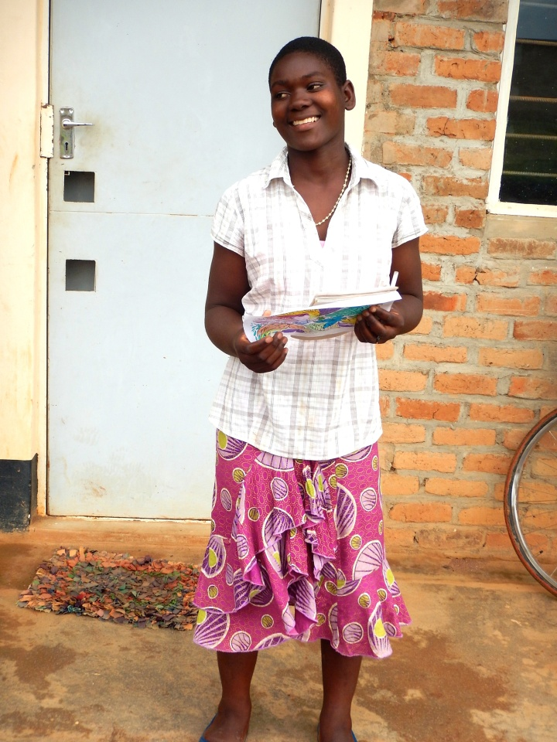

Christina
7th February 2016:

I have been worried about this little girl since I first spoke with her back in September when we were interviewing girls for whom to pay school fees.
Christina is an orphan as both of her parents are dead.
She lives in a shack with her grannie and one brother and his wife.
Her Grannie is unable to walk and goes around on all-fours and if we did not support her as well, Christina would not be able to go to school.
When I got her first term report to say that she was working very hard and had passed all subjects and even done well in some, I was so excited.
My memory was of a frightened and sad little woman who might not find acceptance.
I wrote to Rose our secretary and this is her reply:

Boss, let me talk about Christina to say the truth is that she is so happy nowadays with the help you have given. She has a uniform but it is not in good condition and shoes too. Her Gogo (Granny) is also very happy with the support you are giving and her life has changed so much for the better.
As you requested we will have a new uniform made for her and get the shoes as well
I know the girl from beginning and she is a diligent and serious worker when she comes to the Center for Learning on Saturdays.
I hope you are happy now and I did congratulate her, for you, on her results.
It will cost an average of 180 Euro, each to send our 77 girls and three women to Secondary School for the year. Some will now need food as well as fees and clothes, but we will cover it all.

- 1st Feb, 16
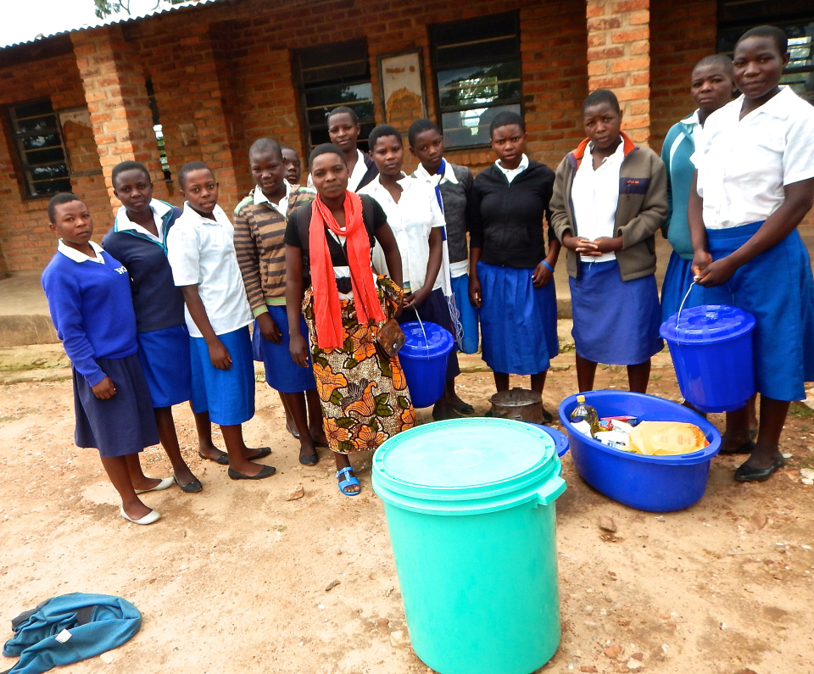

Food for the girls
1st February 2016:
We are enabling these girls to take up their places in this Government CDSS (Community Day Secondary School) in Choma, otherwise they would fail to attend.
Steve, our volunteer from Alaska, found out that some girls were hungry, so he arrived today to very happy recipients.
These are what are called self-boarders. They go home on Fridays, often walking up to 5 hours home and the same back some food, if they have it, on Sundays. It is really horrific, as they are targets for all kinds of nasties on the way, who often rob them and worse. These girls fight so hard for the little education they get.
This school has a version of a Girls Hostel that we are trying to assist, but no one admits to knowing what assist means (that they do the labour and we help)
As with most of Africa, the Aid Business has made them dependant beggars, so they wait for some foreign idiots in the white jeeps to do it for them.
But that's not us. So progress with the hostel is slow and painful.
The girls are happy today and thankful for Steve's generosity.

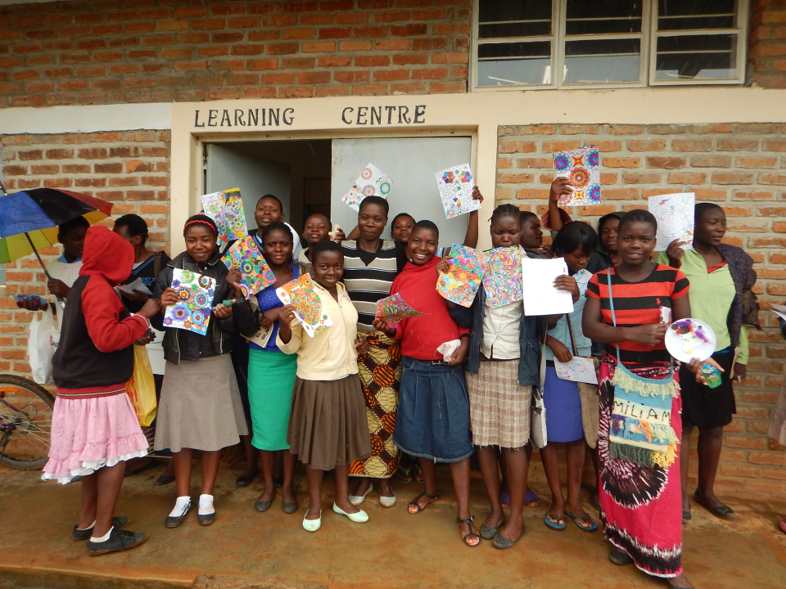

A Saturday Class
30th January 2016:

These are one class from the Centre for Learning, part of the ever growing troupe of girls, we are enabling to go to Secondary School. Some parents make a huge effort and pay fees for the first term and just can't manage the second term. Our numbers have risen from 75 to 81.
They look happy and are happy. They are getting individual attention for maybe the first time in their lives. Of course many have travelled long distances, on foot and have still not eaten anything. It is the hungry season in Malawi when many rural people are down to one meal a day. Sad but true. All this while the rich, in Malawi are constantly getting richer! But this is the way of our world, everywhere.

  - One year ago

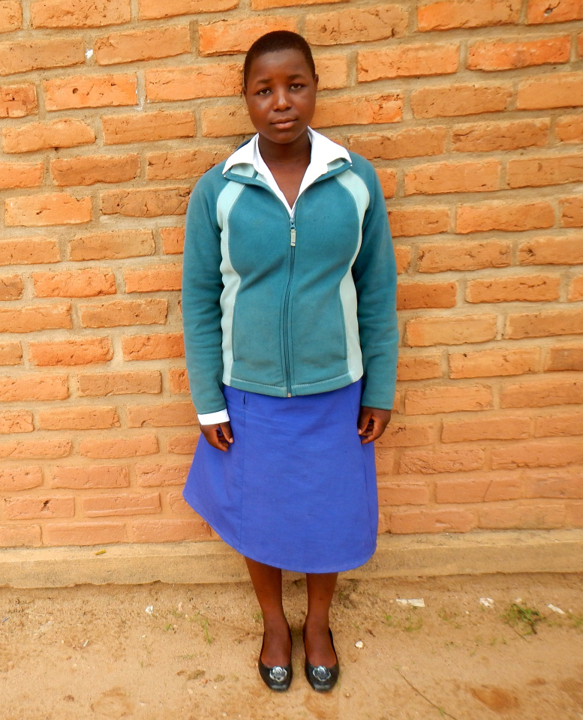

Educating the Girl-Child Salome
January 27th 2016:
CHOMA CDSS
Name: Salome Gondwe
Age: 15 years
School results: Average Student passing everything, and getting 60 in Chichewa
Form: One
Village: Gama Village
Primary school: Mzgola Primary School
Secondary school: Choma CDSS
Father: Version Gondwe
Business: No
Mother: Iffiness Nyondo
Business: No
Brothers: Abichale and Steve
Sisters: Chance and Genie
Lives with: Brother
Where: Gama Village
Rented House
Additional information
She has both parents but they are not working and they live far away from school, so she
decided to live with her brother near the school, but he is not working and he can not
manage to pay school fees for her

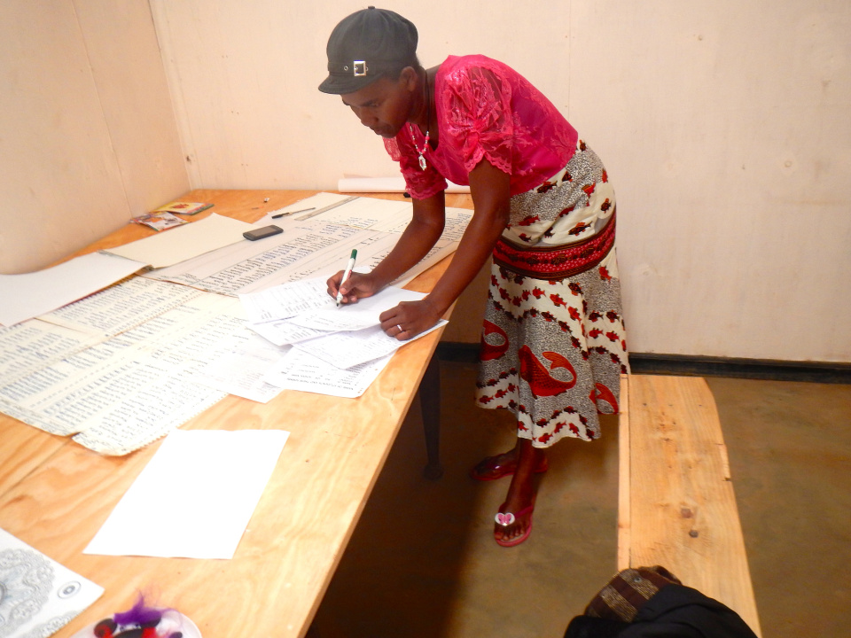

Rose on the Girl Child project
24th January 2016:

Our Girl-Child project has developed a lot in the past four months. Our big push at the moment is enabling girls (and women) to take up their places in Government Secondary schools. Fees are an enormous barrier, but there are many others like the need to help at home with small siblings, carrying water, menstruation taboos and sanitation in school and mare and more.
Of the kind of poor purple we work with it is reckoned that only 0.06% of girls finish secondary school. Of course they are only girls and who cares about girls. (being a bit nasty), but the 75 girls we support have huge potential and may rock a some boats in a few years.
Rose is our Secretary, in charge of everything including finance is helping Florence keep up to date with each of our 78 girls and three women.

Malala Yousafzi, the Pakistani schoolgirl, shot in the head by the Taliban, addressd the United Nations, saying
"Let us pick up our books and pens. They are our most powerful weapons. "One child, one teacher, one pen and one book can change the world. Education is the only solution. Education first."

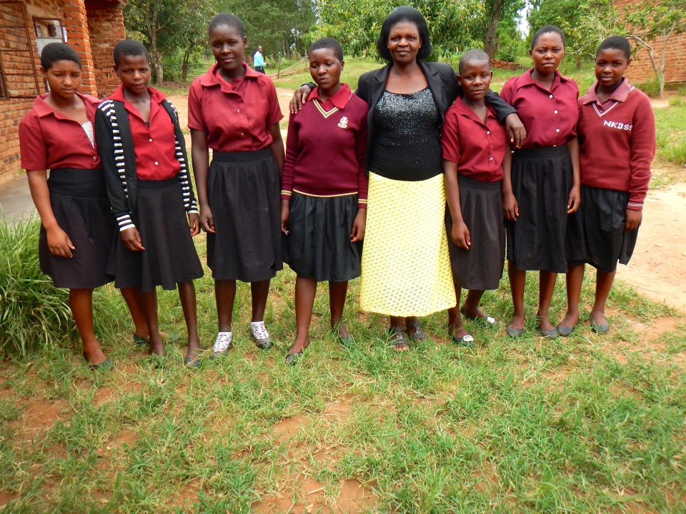

NKhorongo Day Secondary School
23rd January 2016:
This is one of the schools on out list. This is a group pic of some of our girls with their teacher,
They are in a class of 52 with little or no resources.
Generally there are no textbooks and they generally have a few for the whole class. We do our best to have a rotation. The teacher writes in chalk, on a blackboard, that started off black. They transcribe when they have a pen and copy.
Its not easy but every day in school means that they will not be married off to an older man who can afford the dowry.
Some are doing very well with their studies, but at least they are getting a chance.

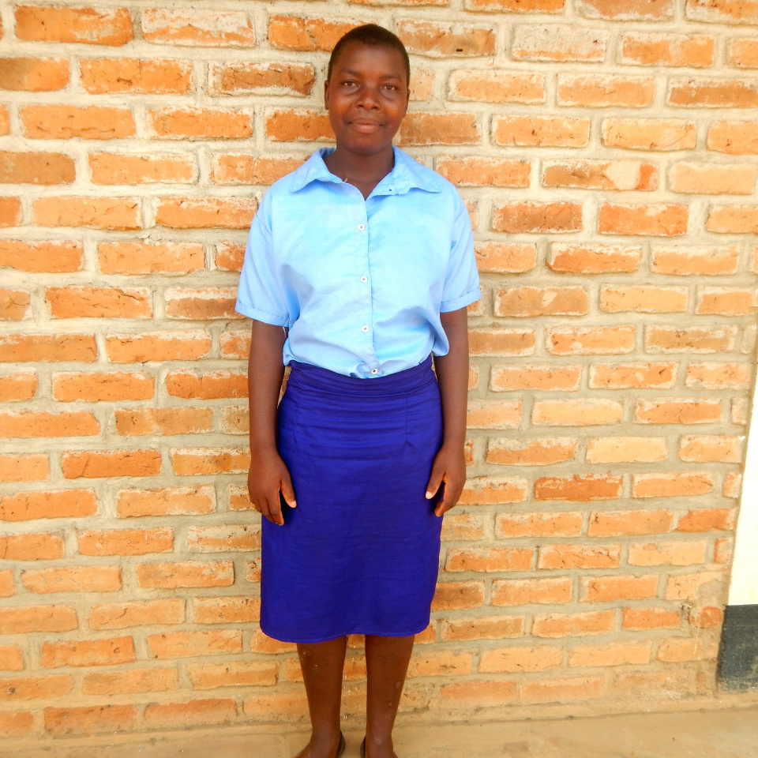

Educating the Girl Child
19th January 2016:
At wells for Zoe we are almost as passionate about Girls Education as we are about water. This year we are enabling 77 girls and three women to get to Secondary School, now that they have qualified. The average cost over the 81 is 180 euros, per year, for fees, books, requisites. Sometimes we need to support the families or the grandparents when they are the nearest.
The following is a little bit about her challenges and how she is managing them:
LUPASO COMMUNITY DAY SCHOOL
Name: Naomi Gondwe
Age: 14 years
School results
Agr 73, Bio 37, chich 68, Eng 58, Geo 64, His 65, Maths 8, Phc 39, S/S 71
Form: Three
Village: Kamzimu Gondwe
Primary school: Kasungu
Secondary school: Lupaso CDSS
Father: Kondwani Gondwe (Died)
No Business
Mother: Ida Mbewe
Brothers: Henry Gondwe
Sisters: None
Lives with: Grand Father
Where: Lupaso
Rent on home Home
Additional information
Her father passed away and her mother is married to
another man, so she stays with her grand father who is a watchman, so he can not manage to pay school fees for her. From what I see, Naomi is doing fine. She will need a lot of help with her Mathematics, but will be able to attend at our Centre for Learning.

The average cost over the 81 will work out at about 180 Euros each, per year or 60 Euro per term. The fees alone work out at about 20 Euro each per term.

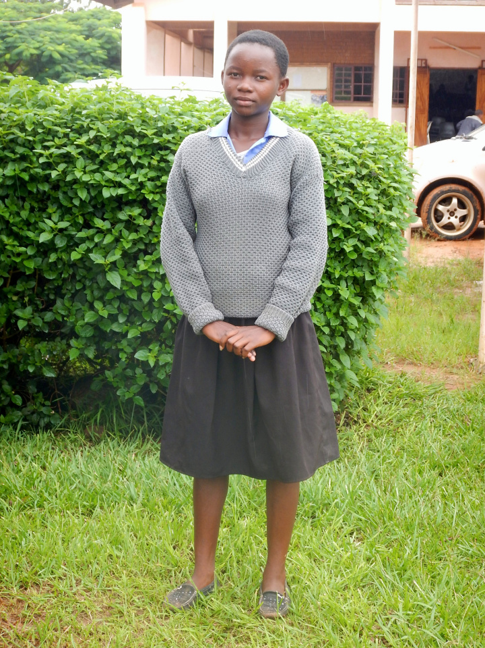

Monica
18th January 2016:
This is Monica Scotch, getting second place in her class of 38.
85 % in English stands out but she needs a little help in mathematics, but our Center for Learning will help.
If we did not support her, she would not get to secondary school. The fees and the other costs put it out of reach of poor girls. Boys of course get preferential treatment in education, in they generally find fees, as well as most other areas.
Sad but true.

